

Master Studies

Field: Advanced Analytics And Big Data

Cemhan Senol
Student No:131050

PageRank-Driven Player Ranking in Football Passing Network & Community Detection

Master’s thesis
under scientific supervision of
Zbigniew Gontar, Ph.D.
Institute of Information Systems and Digital Economy

Warsaw 2025
List of Contents

Abstract
Introduction

Chapter 1: Literature Review
Chapter 2 :Methodology
- 2.1 Data Collection
- 2.2 Network Construction
- 2.3 PageRank for Player Ranking
- 2.4 Community Detection
- 2.5 Tools and Implementation
Chapter 3: Result
Chapter 4: Discussion
Chapter 5: Conclusion
Bibliography
Figures

Abstract
Football is a dynamic team sport where passing patterns shape the flow of play and heavily influence match outcomes. Traditional performance metrics such as pass counts and assists provide only a partial view of player contributions, often overlooking contextual importance within possession structures. This study applies network science methods to the 2018 FIFA World Cup Final between France and Croatia, focusing on Croatia’s passing network to evaluate both individual influence and collective organization. Using event-level data from StatsBomb, a directed weighted pass network was constructed from completed passes among starting players. PageRank centrality implemented to measure the relative importance of players within passing chains, while community detection identified clusters of tightly connected players. The results highlight Marcelo Brozović as the most influential player, followed by Luka Modrić and Ivan Rakitić, underscoring the role of central midfielders as structural pivots. Community detection reveales a compact left-flank cluster of six players and a secondary cluster of four players oriented more centrally and to the right, reflecting Croatia’s tactical understanding on left-sided buildup and space creation for attacking transitions on the right. These findings demonstrate that network-based metrics can uncover hidden tactical patterns and player roles beyond conventional statistics. Future research could incorporate unsuccessful passes with penalty weights, extend analyses to dynamic and multi-match networks, This methods may offer deeper insights for both football science and applied performance analysis.

Introduction

Football is widely regarded as the most popular sport in the world, and its analysis has become increasingly data-driven in recent years. With the growth of event-level datasets, analysts and researchers now have access to detailed information on every pass, shot, and movement during a match. Traditional performance indicators—such as possession percentage, pass completion rate, or assists—remain valuable but often fail to capture the structural influence of players within the deeper tactical system. A midfielder who connects teammates in key buildup phases, may contribute more to team stability than is reflected in raw statistics.

In this context, network science provides powerful tools for analyzing football. By modeling a team’s passing as a network of interactions, methods from graph theory can be applied to measure both individual importance and collective organization. One such method is the PageRank algorithm, originally developed for ranking web pages, which evaluates nodes based on both their connections and the quality of those connections. In football, PageRank can highlight “hidden playmakers” whose influence appears not from volume alone but from their role within possession chains with their interactions. Similarly, community detection algorithms reveal clusters of players who interact more frequently with each other.

This thesis applies these methods to the 2018 FIFA World Cup Final between France and Croatia, using open-source event data from StatsBomb. Croatia was chosen as the case study due to their structured buildup play and reliance on midfield dominance. The research objectives are:

- To construct a passing network for Croatia’s starting players and evaluate influence using PageRank centrality.
- To detect community structures within the network and interpret their tactical significance.
- To visualize the passing networks and analytical results on the pitch, making the findings more interpretable in a tactical context.
- To compare findings with traditional metrics, assessing the added value of network-based methods.

The contributions of this research are twofold. First, it demonstrates how PageRank and community detection can provide context-aware insights into player influence, identifying key connectors such as Marcelo Brozović who may not top traditional statistics. Second, it shows how community detection reveals tactical asymmetries, specifically Croatia’s reliance on a compact left-sided cluster for progression and the creation of space on the right. Together, these findings illustrate the potential of network analysis for advancing both academic research in sports analytics and practical applications for coaches, scouts, and performance analysts.

Chapter I - Literature Review

This chapter refers related works in the literature. The articles will be explained detailed also will be mentioned how they inspired my work. Despite i inspired from many works during literature riview, in this chaper there will be mentioned main two articles and they will explain PageRank Algorithm working principles and implementation methods for football analysis

.

1.1. Literature Review Article – I (PageRank Algorithm)

PageRank is an algorithm used by Google to rank webstes in their serach engine optimization that invented by Larry Page and Sergey Brin. Everyday amonth of websites growing and the websites should be ranked by certain algorithms. Google’s PageRank algorithm uses important pages when they are flagged by other important pages and disregards spam pages. This article explains the math behind the Google’s PageRank algorithm.

Before the PageRank algorithm, search engines was using Text Ranking methods as basis. This engines were searching texts through the pages according to count of occurance of the words. This approach was not reliable for list the most viewed pages first. Instead of this, the modern approaches use the methods for list best results first and the most popular modern algorithm is “PageRank” algorithmn.

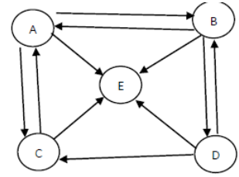
Figure 1-Sample Network

In order to calculate PageRank scores, article have a network as its basis. According to given network the vertex matrix(H) will be generated as follows;

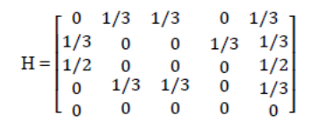
The rank of the pages are totally indepent of backlinks. This determined by

$r\left(p\right)= \sum_{p}^{q}{\frac{r(q)}{r(p)}}$
The ranking score r(p) is calculated by the out degree of the page. With this way the page will have higher rank score if it has incoming traffic from important pages otherwise it will have lower ranking score.Calculation of the ranking scores will be as follows. (For calculations d- damping factor will be assigned as 0.15)

Page A: 0.15 (base) + 0.1275 +0.0425(Page C,B) = 0.35
Page B: 0.15 (base) + 0.0425+ 0(Page A,D) = 0.1925
Page C: 0.15 (base) + 0.0425 (Page A) + 0.0425 (Page D) = 0.235
Page D: 0.15 (base) + 0.0425 (Page B) = 0.1925
Page E: 0.15 (base)

It is possible to briefly say that according to this scores Page A has the highest PageRank score and it’s the most important page and Page E has the lowest PageRank score therefore it is the least important page.

1.2. Literature Review Article – II (PageRank Approach to Ranking National Football Teams)

In this work “PageRank Approach to Ranking National Football Teams” (Lazova & Basnarkov, 2015), the researchers use PageRank algorithm in order to rank national teams. Their target is having alternative ranking system in football ranking, currently FIFA uses its own ranking system whics uses last 4 years results. In this work, the researchers will focus on world cup performances of the teams. As mentioned before PageRank developed for ranking web pages for search engines. In this work it is implemented for football analysis to rank national teams. Each nodes represent a national team and builded linked with other nodes if they have ever had any match before. The weighted links based on the match results(victories, defeats and draws), scored and conceded goals, victory against stronger opponents, math-up pairs etc. Throughout the study, varios weighting functions have tested, despite the results are quite close to each other, the study follows the most convenient weighting function. Tested weighting functions are listed below.

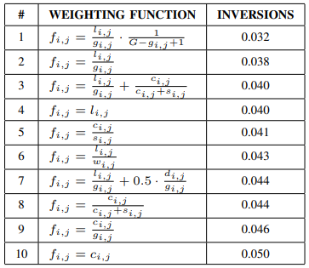
Figure 2-Weighting Functions

$f_{i,j}$ weight of the link from nıde i to node j
$g_{i,j}$ number of games played between the two teams
$l_{i,j}$ number of games lost by team i amongst all the games i and j played
$w_{i,j}$ number of games won by team i amongt all the game i and j played
$c_{i,j}$ number of goals conceded by team i during all the games i and j played
$s_{i,j}$ number of goals scored by team i during all the games i and j played
$d_{i,j}$ number of games drawn between the two teams
$G$ maximum number of games played between any match-up pair

For instance, assumed 4 teams and their game results supposed as follows,
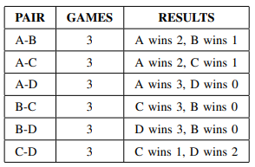
Figure 3-Sample Games and Results
According to Figure-3, PageRank algorithmn performed with the nr2 weighting function from Figure-2. Therefore weight of given link represents part of games i has lost to j. I.e From A to B with weight of 1/3 and vice vera the link from B to A with weight of 2/3. Also dumping factor defined as 0.15 After the calculations, it briefly shows that A has the highest PageRank and the descending order list mentioned below.
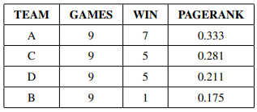
Figure 4-Sample Games PageRank Scores

This final PageRank scores used for scale the node sizes to describe the teams importancy and their favority level. -This sizing method also inflused to our main reasearch. In the main reasearch, players represented by nodes and nodes sized by their rank scores which is calculated by PageRank algorithm.- Final network depicted as below;

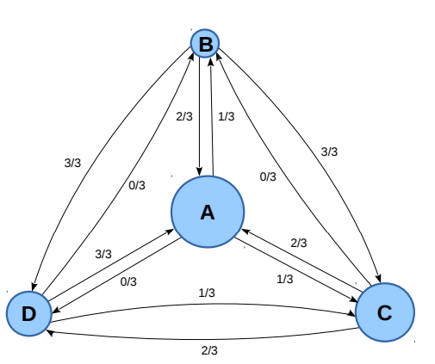
Figure 5-Sample Final Network

The calculations are explained detailed. In the final method of the study, Lazova & Basnarkov decided to go through with the nr1 weighted function from Figure-2 and the dumping factor with 0.05.As a final of their work, the top 20 teams listed due to their PageRank score and the last column represents their position in the official ranking.

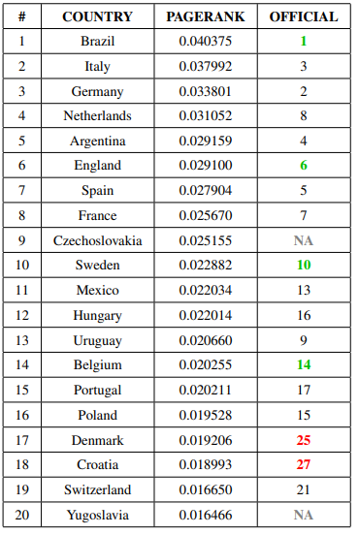
Figure 6-Lazova & Basnarkov Research Results

Chapter II - Methodology
This chapter refers methodologies of the research. In the chapter the steps will be explained detailed respectively. The steps order will be as follow;
Data Collection $→$ Network Construction $→$PageRank Implementation for Player Ranking $→$ Community Detection $→$ Tools and Implementation Summary

2.1 Data Collection
The dataset used in this study was obtained from StatsBomb’s open-source event data repository. Although there is tons of data provider exist regarding football, it is very limited to find dataset provider for event-based football data. Even though in the limited options there is good data providers also exist for provide event-based football dataset. The most common open-source data providers are “StatsBomb” and “WyScout”. In this research decided to go through with StatsBomb provider dataset mainly because of its compherensive documentation. Detailed event-level data for several competitions, including passes, shots, tackles, and other actions.
For this research, the 2018 FIFA World Cup Match has selected as a case study. Using the library’s API functions, the list of competitions and matches was retrieved. Specifically, the final match between France and Croatia was chosen for detailed analysis.
The event data for this match was readed via StatsBomb library, resulting in a structured dataframe containing all match events such as:
- Event type (e.g., pass, shot, foul)
- Team and player information
- Timestamps
- Pass outcomes
- Tactical lineups
Since the objective was to analyze passing networks, only completed passes arefiltered. Unsuccessful passes are excluded in order to build solid pass network. Furthermore, to keep the network representation consistent, only players who are part of the starting eleven were included in the analysis. By filtering only the players in the starting eleven, the analysis prevented from being affected by the fact that substituted players could not sufficiently participate in the passing network.
The preprocessing steps were as follows:
- Retrieve competitions and matches: StatsBomb dataset used to get available seasons and matches
- Select match: Focused on the 2018 World Cup Final (France vs Croatia)
- Filter events: Filtered only completed passes, excluding incomplete or intercepted attempts
- Filter players: Filtered the starting lineup for the team under analysis (Croatia), ensured the network includes only relevant players
- Build final dataset for network: A dataframe builded with the names of the passers and receivers, also weights are assigned based on the number of passes in each channel, in order to identify the importance of the passing channels
After preprocessing, the dataset contained all successful passes made by Croatia’s starting players during the match. This served as the foundation for building the directed weighted pass network, where nodes represent players and edges represent the number of successful passes between them.
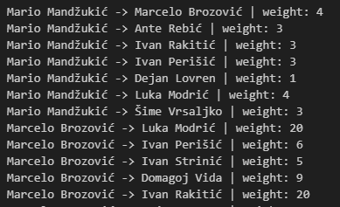
Figure 7-Network Explanation

2.2 Network Construction

After build the dataset for the network, a directed weighted network is constructed to represent the connection among players. In the network:
- Nodes represent players
- Edges represent passes between two players
- Edge weights represent frequency of successful passes from one player to another
The average positions of players are calculated from the event data in case of flag the players on the pitch accurately. With this way it is possible to see the pass channels transparently. Each event in the StatsBomb dataset contains a pair of coordinates (x,y) corresponding to the location on the pitch where the event occurred. For each player, the average x and y values across all actions are calculated with the player’s typical position during the match
Formally, the average position of player p was calculated as:
${\overline{x}}_{p}=\frac{1}{n}\sum_{i=1}^{n}{x_{i}}$ , ${\overline{y}}_{p}= \frac{1}{n}\sum_{i=1}^{n}{y_{i}}$

where $n$​ is the total number of recorded events for player p.
These average coordinates are used in order to flag the nodes(players) of the network on a two-dimensional football pitch, this approach allows to have an intuitive representation of passing relationships that aligns with players actual tactical positions.
For visualization, the following design choices were made:
- The pitch was drawn using the mplsoccer library with StatsBomb’s standard field dimensions (120 × 80).
- Nodes are plotted at the average location of each player and sized uniformly to ensure readability(after the PageRank calculation they are resized with their ranking scores)
- Edges are drawn as arrows to indicate the direction of passes, with thickness proportional to the number of passes between the players
- Colors are chosen to ensure contrast with the pitch background (blue nodes, green edges, white labels).
An example visualization for Croatia in the 2018 FIFA World Cup Final against France is shown in Figure. This network depicts an overview of the team’s passing network, highlighting which players have central role in the network throughout the match.

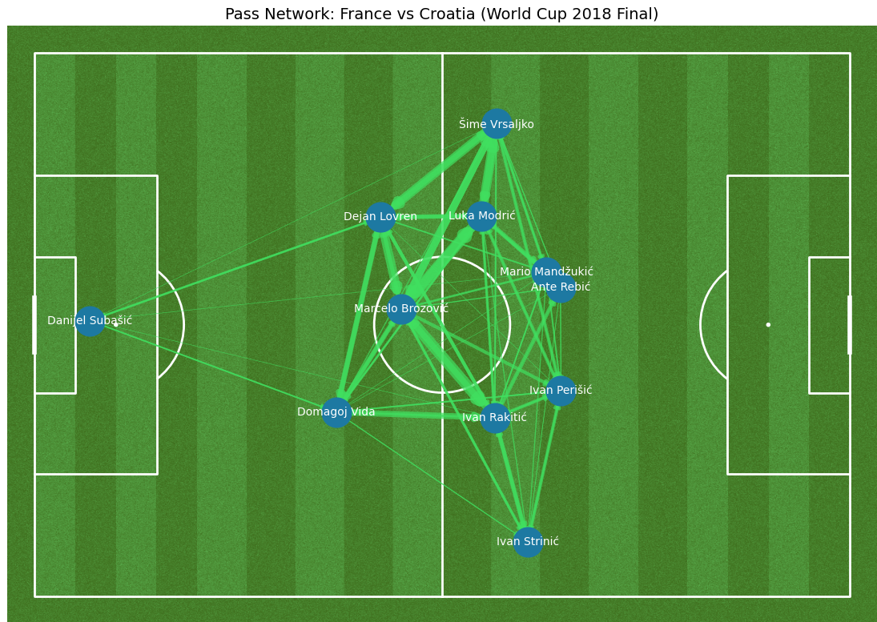
Figure 8-Network Visualization
2.3 PageRank for Player Ranking

In order to calculate players contribution in pass chain PageRank algorithm applied. PageRank developed to rank webpages originally, It has been adapted and implemented in football analytics to evaluate the importance of nodes(players) in team pass network. PageRank reflects not only how frequently a player is involved in passes, also it uses the quality of the connections— Generally midfielders have more contribution in pass organizations than wings or strikers. It makes them more valuable nodes in the network. The players who have more interaction with these players, they also have better possition in the network.

The PageRank score of a player i is computed iteratively as:
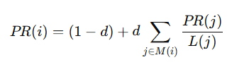
where:
- d = damping factor (set to 0.15 as initial),
- M(i) = set of players passing to player i,
- L(j) = number of outgoing passes from player j.
As described on the formula, PageRank uses ranks of interacted players, therefore if a player has interaction with the players who has high PageRank score, it increases rank score of the player. This provides a more context-aware measure of centrality compared to simple pass counts or degree statistics.
Implementation
The PageRank scores are computed using NetworkX library’s pagerank() function in python, with edge weights corresponding to the frequency of passes between players. The resulting scores were stored in a DataFrame for further analysis, where:
- Each row corresponds to a player.
- Columns include the player’s name, PageRank score, and rank order within the team.
- Players were sorted in descending order to highlight the most influential figures in pass chain.
This approach allowes for the identification of key playmakers, Players who may not necessarily make the highest number of passes, but whose involvement is strategically significant due to their connectivity in the network. In example As shown on the table below, Despite Ivan Rakitic has less pass activity than either Dejan Lovren and Sime Vrsaljko, he has higher rank in the network.
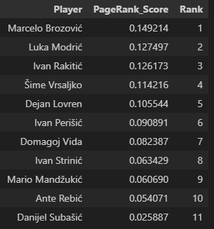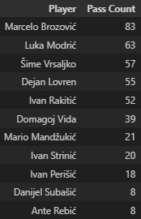
Table 1-Croatia Team PageRank Scores Table 2-Croatia Team Pass Counts
As inspired from Lazova & Basnarkovis work(as illustrated in Figure-5), PageRank scores used for size the players on the pitch to give significant insights for game analysis. They represent their key roles in the pass chain.

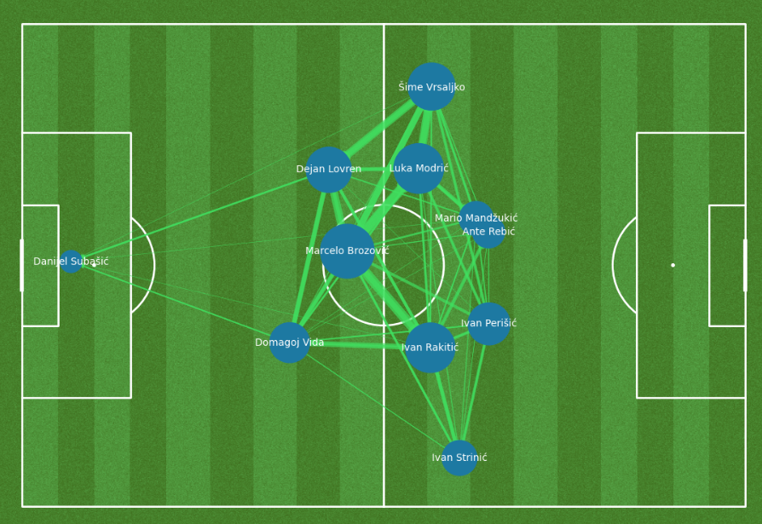
Figure 9-Croatia Team Visualiation w PageRank Scores

2.4. Community Detection
Community detection is the process of grouping the nodes of a network into clusters (communities) such that nodes within the same cluster are more densely connected to each other than to nodes in other clusters. This research also aims to reveal tactical patterns within the team by applying community detection. Communities represent groups of players who exchange passes more frequently with each other than with the rest of the team. Thereby it reflects natural tactical units such as defensive lines, midfield clusters, or attacking trios.

Preprocessing Considerations
The goalkeeper was excluded from the community detection process. This decision was made because of the goalkeepers typically engage in fewer passes and are structurally isolated from the main passing chains. Including the goalkeeper often add biases to community detection algorithms, as they may be assigned to a separate single-node community. In order to avoid from this issue the goalkeeper is excluded from the network and treated as a neutral node and visualized separately.
Method
The directed network converted to an undirected network to capture bidirectional interaction strength. The greedy modularity optimization algorithm, implemented via NetworkX library, This algorithm used in order to maximize the network’s modularity score. Modularity measures the density of edges within communities compared to edges between communities. Modularity formula defined as:

$$Q=\frac{1}{2m}\sum_{i,j}{\left[A_{i,j}-\frac{k_{i}k_{j}}{2m}\right]δ\left(c_{i},c_{j}\right)}$$

$A_{i,j}$ is the adjacency matrix of the network
$k_{i}k_{j}$ are the degrees of nodes in i and j
$m$ is the total number of edges
$c_{i},c_{j}$ represent the communities of nodes i and j
$δ\left(c_{i},c_{j}\right)$ = 1if both nodes belong to the same community, 0 otherwise

Visualization
Communities visualized by assigning each detected group a unique color using the tab10 colormap. Nodes plotted at their previously calculated average positions, ensuring that the detected communities could be interpreted in relation to tactical roles on the pitch. Edges between players drawn scaled, while the goalkeeper highlighted in a neutral gray color to indicate their exclusion from the community. The resulting visualization shows distinct clusters of players corresponding to functional tachtical units. This method provides a tactical lens to analyze how teams self-organize through ball circulation..
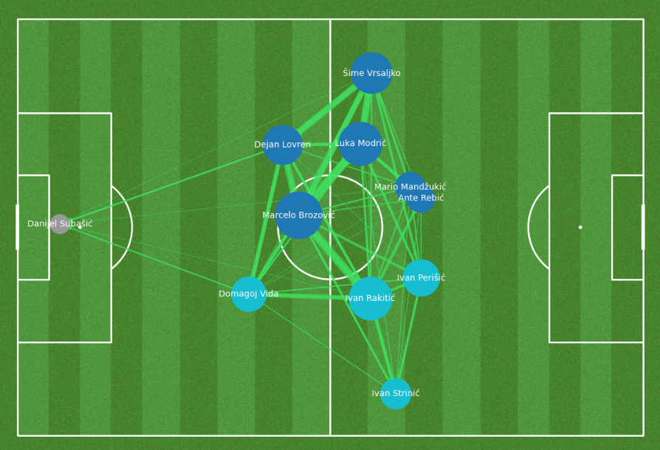
Figure 10-Visualization with PageRank and Community Detection

2.5 Tools and Implementation
The implementation of the methodology carried out using Python 3.11, due to its wide range of scientific computing libraries and suitability for network analysis and data visualization. All experiments and analyses executed in a Jupyter Notebook environment, enabling an interactive workflow for data exploration, coding, and visualization.
The key tools and libraries employed as follows:
- Data Access and Handling
  - StatsBomb: Used to get open-access event data from StatsBomb, including competitions, matches, and detailed event logs.
  - pandas: For structured data manipulation, cleaning, and preparation of event-level datasets.
- Network Construction and Analysis
  - NetworkX: For constructing directed weighted pass networks, calculating PageRank scores and also for performing community detection.
  - NetworkX Community Algorithms: Specifically, the greedy modularity optimization function used to detect tactical subgroups ın the pass networks.
- Visualization
  - mplsoccer: Created football pitch visualizations with mplsoccer library that serve as the canvas for plotting passing networks and community structures.
  - matplotlib: For additional plotting functionality, including customization of network diagrams and tabular outputs.
Workflow
The overall workflow consisted of:
- Data retrieval from StatsBomb.
- Preprocessing and filtering using pandas.
- Pass network construction and graph-based calculations using NetworkX.
- Player influence ranking with PageRank.
- Community detection using modularity optimization.
- Visualization of results on football pitch diagrams via mplsoccer and matplotlib.

Chapter III – Results

The analysis of Croatia’s passing network in the 2018 FIFA World Cup Final provides valuable insights into both individual player influence and overall team organization.

- Marcelo Brozović is the most central and influential player, positioned at the hub of circulation and receiving the highest PageRank score.
- Luka Modrić and Ivan Rakitić also play a key linking roles, but thir influence ranks follow to Brozović.
- The left side of the team (Mandžukić, Rebić, Modrić, Vrsaljko, Lovren, and Brozović) forms a compact cluster of six players, with dense intra-connections.
- The remaining four players (Rakitić, Perišić, Vida and Strinić) constitute the second cluster, oriented more towards the central and right areas.
- This shows an asymmetric buildup, left flank has more compact structure and represents that croatia team mostly use this compact channel to build their attack organizations. Moreover on the right flank, Croatia team targets to open space for Strinic to play 1v1 or move the ball forward for whip a cross.
Overall, the network highlights Croatia’s tactical emphasis on left-side progression and the dominant structural importance of Brozović in maintaining ball circulation.

Chapter IV- Discussion

The analysis shows several important tactical and methodological insights. The PageRank results identify Marcelo Brozović as the most influential player, followed by Luka Modrić. This outcome identify how network-based approaches capture a deeper layer of influence beyond traditional statistics. While Modrić is well known as the creative leader of the team, PageRank highlighted Brozović’s crucial role as the key player in the network. His position in the passing chains enabled him to connect different teammates and recycle the ball effectively, ensuring continuity in the build-up phase. As shown in the visual Modric and Rakitic have positions in the sides of the center also more offensive positons than Brozovic. Because of these reasons even though they has key roles, they can not influence the game as efficient as Brozovic. This finding emphasizes that influence in football is not limited to the most visible creators, but also extends to players who stabilize and connect the team from deeper positions.
Community detection is further analysis in order to better understanding of team organization. The network split the players into two distinct clusters: a compact left-flank cluster of six players and a second cluster of the remaining four. This indicates an asymmetric buildup with denser intra-cluster circulation on the left side, consistent with progression through the left flank. The presence of this strong left cluster reflects a tactical preference to advance play and create combinations on that side. At the same time, if the left side was effectively pressed or isolated by the opponents, Croatia’s passing game could be disrupted.
Compared with traditional match statistics, the network-based measures provided a more nuanced picture. Players with the highest pass counts did not automatically emerge as the most important according to PageRank. Instead, importance was determined by how players were positioned within the overall flow of possession. This distinction shows the advantage of graph-based methods, which emphasize structural roles and connectivity rather than simple frequency counts. Coaches and analysts could use such measures to identify players whose contributions are small but important for keeping the team balanced.
Taken together, the use of PageRank and community detection proved effective for analyzing both individual influence and collective structure. Visualizing the results on the pitch made the findings more interpretable, bridging the gap between mathematical models and tactical insights. Nevertheless, this study is limited by its focus on a single match and by the choice of community detection algorithm, which may yield different partitions under alternative approaches. In addition, the current model considers only completed passes when constructing the network. While this allows for a clear representation of successful ball circulation, it ignores the potential tactical significance of unsuccessful passes. Future models could incorporate pass errors into the network with penalty weights, reflecting both the positive and negative contributions of players to possession dynamics. By integrating this information, the analysis would better capture the risks and inefficiencies in passing, providing a more aggregated understanding of player influence. Extending the model across multiple matches and including both successful and unsuccessful passes would therefore offer a more comprehensive picture of player performance and evolving tactical patterns.

Chapter V- Conclusion.

This study applied network science methods to analyze Croatia’s passing patterns in the 2018 FIFA World Cup Final, combining PageRank centrality and community detection to interpret both individual influence and team structure. The findings highlight the value of these approaches in revealing tactical insights that go beyond traditional football statistics.
The PageRank analysis identified Marcelo Brozović as the most influential player in the network, followed by Luka Modrić and Ivan Rakitić, It shows that structural positioning within passing chains can be as important as raw pass counts or assists. These results underscore the ability of network-based metrics to identify players who act as pivotal connectors, maintaining possession and linking different areas of the field.
Community detection shows a compact left-flank cluster of six players (Mandžukić, Rebić, Modrić, Vrsaljko, Lovren, and Brozović) and a second cluster of four players (Rakitić, Perišić, Vida, and Strinić) oriented more toward central and right areas. This division indicates an asymmetric buildup, with denser intra-cluster circulation on the left side. The pattern suggests that Croatia primarily relied on the left channel for progression and combination play, while on the right flank the team targets to create space for Strinić to engage in 1v1 situations or deliver crosses into advanced areas.
Overall, this study shows that combining network visualization, PageRank, and community detection offers a comprehensive and interpretable framework for evaluating player influence and team organization. The methodology is flexible and can be extended to other teams, competitions, or longitudinal studies to examine consistency of influence and evolving tactical patterns.
Future research could also use unsuccessful passes into the network with penalty weights, allowing the model to capture not only successful circulation but also the risks and inefficiencies of possession. This would provide a more aggregated and realistic view of player contributions. In addition, extending the model to dynamic networks across multiple matches, accounting for pressing and defensive actions, or integrating expected possession and chance creation metrics would yield an even richer understanding of football tactics. By linking advanced quantitative methods with practical football analysis, this approach contributes both to the scientific study of team sports and to actionable insights for coaches, analysts, and players.
Bibliography

Caicedo-Parada, S., Lago-Peñas, C., & Ortega-Toro, E. (2020). Passing networks and tactical action in football: A systematic review. International Journal of Environmental Research and Public Health, 17(18), 6649.

2 Gama, J., Passos, P., Davids, K., Relvas, H., Ribeiro, J., Vaz, V., & Dias, G. (2014). Network analysis and intra-team activity in attacking phases of professional football. International Journal of Performance Analysis in Sport, 14(3), 692-708.

3 Page, L., Brin, S., Motwani, R., & Winograd, T. (1999). The PageRank citation ranking: Bringing order to the web. Stanford infolab.

4 Dode, A., & Hasani, S. (2017). PageRank algorithm. IOSR Journal of Computer Engineering (IOSR-JCE), 19(1), 01-07.

5 Lazova, V., & Basnarkov, L. (2015). PageRank approach to ranking national football teams. arXiv preprint arXiv:1503.01331.

6 Narizuka, T., Yamamoto, K., & Yamazaki, Y. (2014). Statistical properties of position-dependent ball-passing networks in football games. Physica A: Statistical Mechanics and its Applications, 412, 157-168.

7 Pena, J. L., & Touchette, H. (2012). A network theory analysis of football strategies. arXiv preprint arXiv:1206.6904.

8 Brin, S., & Page, L. (1998). The anatomy of a large-scale hypertextual web search engine. Computer Networks and ISDN Systems, 30(1–7), 107–117.

9 Fortunato, S., & Hric, D. (2016). Community detection in networks: A user guide. Physics reports, 659, 1-44.

10 Li, M. X., Xu, L. G., & Zhou, W. X. (2025). Motif analysis and passing behavior in football passing networks. Chaos, Solitons & Fractals, 190, 115750.

11 Clauset, A., Newman, M. E., & Moore, C. (2004). Finding community structure in very large networks. Physical Review E—Statistical, Nonlinear, and Soft Matter Physics, 70(6), 066111.

12 Saoud, B. (2021). Modularity maximization to find community structure in complex networks. In Conference proceedings ICCSA (Vol. 2021, p. 42).

Figures

Figure 1-Sample Network 6
Figure 2-Weighting Functions 7
Figure 3-Sample Games and Results 8
Figure 4-Sample Games PageRank Scores 8
Figure 5-Sample Final Network 9
Figure 6-Lazova & Basnarkov Research Results 9
Figure 7-Network Explanation 11
Figure 8-Network Visualization 12
Figure 9-Croatia Team Visualiation w PageRank Scores 14
Figure 10-Visualization with PageRank and Community Detection 16
Table 1-Croatia Team PageRank Scores 14
Table 2-Croatia Team Pass Counts 14

Caicedo-Parada, S., Lago-Peñas, C., & Ortega-Toro, E. (2020). Passing networks and tactical action in football: A systematic review. International Journal of Environmental Research and Public Health, 17(18), 6649.
Gama, J., Passos, P., Davids, K., Relvas, H., Ribeiro, J., Vaz, V., & Dias, G. (2014). Network analysis and intra-team activity in attacking phases of professional football. International Journal of Performance Analysis in Sport, 14(3), 692-708.
Page, L., Brin, S., Motwani, R., & Winograd, T. (1999). The PageRank citation ranking: Bringing order to the web. Stanford infolab.
Dode, A., & Hasani, S. (2017). PageRank algorithm. IOSR Journal of Computer Engineering (IOSR-JCE), 19(1), 01-07.
Lazova, V., & Basnarkov, L. (2015). PageRank approach to ranking national football teams. arXiv preprint arXiv:1503.01331.
Narizuka, T., Yamamoto, K., & Yamazaki, Y. (2014). Statistical properties of position-dependent ball-passing networks in football games. Physica A: Statistical Mechanics and its Applications, 412, 157-168.
Pena, J. L., & Touchette, H. (2012). A network theory analysis of football strategies. arXiv preprint arXiv:1206.6904.
Brin, S., & Page, L. (1998). The anatomy of a large-scale hypertextual web search engine. Computer Networks and ISDN Systems, 30(1–7), 107–117.
Fortunato, S., & Hric, D. (2016). Community detection in networks: A user guide. Physics reports, 659, 1-44.
Li, M. X., Xu, L. G., & Zhou, W. X. (2025). Motif analysis and passing behavior in football passing networks. Chaos, Solitons & Fractals, 190, 115750.
Clauset, A., Newman, M. E., & Moore, C. (2004). Finding community structure in very large networks. Physical Review E—Statistical, Nonlinear, and Soft Matter Physics, 70(6), 066111. 12 Saoud, B. (2021). Modularity maximization to find community structure in complex networks. In Conference proceedings ICCSA (Vol. 2021, p. 42).

